Guidance for Staff and Student Workers Applying for a DBS Certificate

Updated July 2021 – Lucinda Walker

# **What is a DBS Cer**t**ificate?**

Due to the nature of the role that you have applied for, we require you to obtain a DBS Certificate through the Disclosure and Barring Service (DBS). Our DBS checks are administered and countersigned by an outside company called GBG.

DBS certificates provide institutions with information about the suitability of those seeking to train, or work, in positions of trust.

Stages of DBS check completion in order to obtain certificate:

* Self-register and create an account online via GBG;
* Complete online application process;
* Submit application;
* Contact verifier to arrange document check drop-in;
* Documents verified and check completed;
* Certificate sent by post to current address;
* Educational Engagement advised of outcome (either ‘Clear’ or ‘See Paper Copy’ where there is a disclosure).

You will only need to complete one application for Educational Engagement (for example, if you wish to work across different teams), unless it is for a different level of check (e.g. if you currently hold an Enhanced level check but now require an Enhanced with Barred List check, you will need to complete a fresh application).

If you hold a DBS certificate obtained from elsewhere in the university, this may be sufficient if it is at the same level that we require. Please advise your hiring manager if this is the case and they will confirm next steps with you.

If you hold a DBS certificate from an organisation outside of the university, you will need to complete a check with us.

If you have signed up to the DBS Update Service, you won’t need to complete an application. Please let your hiring manager or team know and arrange for your certificate to be checked.

Your DBS check with Educational Engagement will last for three years. How do I complete my application?

# Step 1 – Starting Your Application

Please self-register by creating your account a[t https://gbg.onlinedisclosures.co.uk.](https://gbg.onlinedisclosures.co.uk/) You can do this by clicking the grey ‘Register’ button in the top right corner (see screenshot).

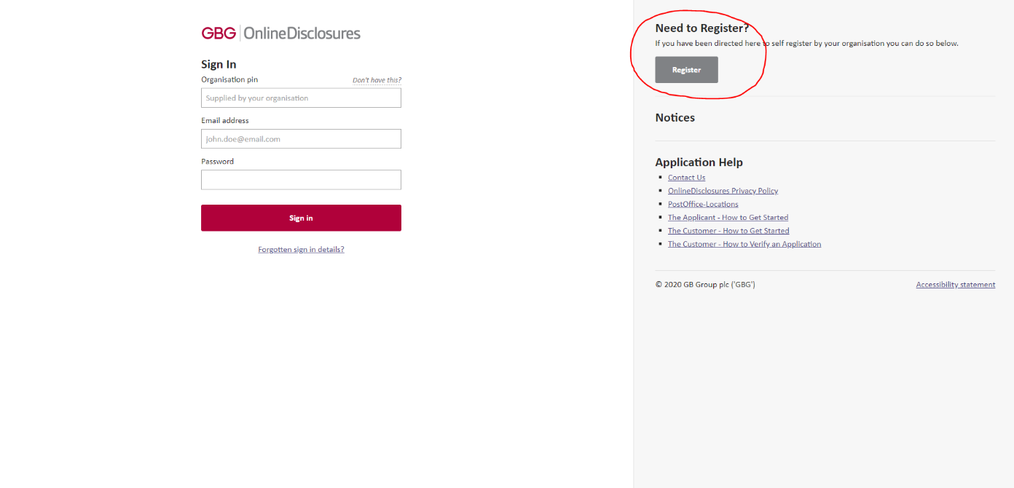

The Organisation PIN you will need to register is 147727 and the secret word is UniofLeeds

When creating your account, your password must be a minimum of 8 characters in length and contain at least one capital letter and one number.

# Step 2 - Completing Your Online Application (PLEASE READ THIS SECTION CAREFULLY):

For guidance on completing the application, please go to the ‘Help’ button at the top right of the GBG page.

Please also see the government DBS website for further information: <https://www.gov.uk/government/publications/dbs-application-forms-guide-for-applicants/dbs-application-form-guide-for-applicants>

**Gender Identity and Change of Name**

* The DBS offers a confidential checking service for transgender applicants, in accordance with the Gender Recognition Act 2004. This is known as the sensitive applications route, and is available for all levels of DBS check - basic, standard and enhanced. To contact the sensitive applications team, please telephone 0151 676 1452 or email [sensitive@dbs.gov.uk](mailto:sensitive@dbs.gov.uk)
* If you have previously been known by a different name, you will need to provide the original evidence of this change - for example a marriage certificate or deed poll.

**Addresses**

* Please ensure that you include **all of your addresses from the past 5 years** (including term-time University addresses such as Halls of Residence) in your application. If you have not done this accurately, we will be unable to verify your documents and you will need to amend this section of the application before we can submit it.
* If you have **lived outside the UK for 6 months or more in one country**, either at either single or multiple addresses, then you will also need to include these addresses as well. This 6-month duration can include any short trips back to the UK e.g. for an Xmas break during a year abroad. Please advise your hiring manager if this is the case as you may also need to complete additional checks.
* It is possible for the dates you have lived at these addresses to overlap.
* If your ID document relates to your home address, you can enter this as your Current address.
* To add term-time addresses, including your *current* term-time address, put the start date as the date you moved in and the end date as ‘yesterday’s’ date (the day before you are completing the application). This will enable your current term-time address to be included whilst keeping your ‘home’ address as Current.
* If you need to amend your addresses after submitting your application, please contact a verifier and ask them to ‘Reject’ your application so it can be returned to you for amendment. Once you have amended it, please make sure you press the Submit button so it is sent back to us.

Applicants that have lived abroad:

If you have lived abroad for six months or more in one country (at either single or multiple addresses), please include these addresses and advise your verifier when you come for the document check. We will need you to obtain a ‘Certificate of Good Conduct’ or Police Check from any countries where you have spent six months or more, as the DBS check will only cover your time in the UK. Details on how to obtain this can be found at [**https://www.gov.uk/government/publications/criminal-records-checks-for-overseas-applicants**](https://www.gov.uk/government/publications/criminal-records-checks-for-overseas-applicants)

Selecting the Right Level of Check

* If you intend to accept work on three days or less in a 30 day period during the course of the year, you need to select the option for an Enhanced DBS check which is [Name of Role]Non RA
* If you intend to accept work on four or more days in a 30 day period or work on a residential during the course of the year, you are now required to have an Enhanced DBS check with a check of the Children's Barred List. Please select [Name of Role]RA
* You will also be asked to complete a form registering your level of check by your hiring team.

**Choosing Your Documents**

* You must be able to provide original documents. Printed online bank / credit card statements or utility bills will not be accepted. You should request either a postal copy or go to the branch direct and ask them to stamp it. Please be aware that HSBC do not stamp statements in-branch so you will need to request that a copy is sent to you by post – please allow 5 working days for this (you should not be charged).
* Please note a driving licence may only be used as evidence of either your name or your address and cannot be used for both.
* Please also ensure you tick the box to receive direct email updates about your application.

# Step 3 – Verifying Your Documents

You will now need to show your original documents to a verifier. Please contact your hiring manager, hiring team, or named verifier to arrange this, which is currently being carried out via Microsoft Teams[1].

You will need to ensure documents are sent to the DBS checker in advance of your Teams meeting, they can be scanned or photographed and then emailed to the checker.

If you select certain documents and then are unable to bring these, they can be changed by the verifier at the point of checking. Please do make sure you have three verifiable documents before arranging to meet with a verifier and have sent copies of the documents you wish to be included in advance.

The University will cover the cost of your DBS check.

In the case of a disclosure containing information about a criminal conviction or caution, you will be invited in for a discussion with a manager and HR to discuss your suitability for the role.

Please direct any queries to your hiring manager, hiring team, or GBG by email at [onlinedisclosures@gbgplc.com](mailto:onlinedisclosures@gbgplc.com) or on 0845 251 5000

1. As of October 2020