Homework exercise: Identifying the cause of an infectious disease

Introduction
In your last session with Dr Randall we discussed how to identify the causes of a bacterial infection. It is now your turn to put your knowledge to the test! Below are five different case studies. We would like you to:
- pick a case study
- identify the organism and infectious disease responsible for the condition
- create a short (5-8 minute) presentation describing the case study and your findings. Additional guidance is provided on page 5!

You should submit your presentations via e-mail to Stem@leeds.ac.uk no later than Friday July 30th 2021. Dr Randall will then provide you with some feedback by the middle of August at the latest.

Case studies
Case 1:
About ten days after a major pruning session in her rose garden, VL experienced difficulties in swallowing. On the following day she could hardly open her mouth because her facial muscles had gone into spasm. She also experienced generalised stiffness and muscle pain. She was also suffering from a raised temperature. On one hand VL had a festering wound. You are provided with a sample suspension from this wound. Your laboratory assistant has prepared a plate containing the pathogen and informs you that the microorganism can only grow in the absence of oxygen (the technical term for this is “obligate anaerobe”) and produces something called “endospores”. After carrying out a Gram stain, you observe the presence of Gram-positive bacilli
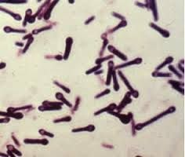

Case 2:
AO, a 42 year-old male visited his local GP complaining of a very itchy rash on his neck and feeling “tired all the time”. Further examination revealed that AO had an elevated temperature, and that the rash on his neck contained a small blister with a black centre. Upon hearing that AO worked with animal hides, the GP admitted AO to the local hospital under the care of their infectious disease consultant. Over the next 5 days AO’s blister turned into a large, black ulcer. The consultant has sent you a sample of this ulcer, which your laboratory assistant has cultured, and prepared a plate of the pathogen responsible. Your assistant points out that this organism can only grow in the presence of oxygen (the technical term for this is “obligate aerobe”) and produces something called “endospores”. After carrying out a Gram stain, you observe the presence of Gram-positive bacilli.
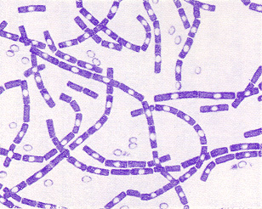

Case 3: NJ, a 30 year-old female, has been on the intensive care ward for the last 20 days following a motorcycle accident. Due to damage to her trachea (windpipe), NJ has been put on a ventilator to help her breathe. This process required a tube to be inserted into the bottom of her trachea. Over the last two days NJ developed a fever (elevated temperature) and the oxygen saturation of NJs blood decreased, suggesting a problem with her lungs. A chest x-ray revealed that NJs lungs contained fluid, and a sticky green substance was found growing in the ventilator tube. A sample of this substance was cultured by your laboratory assistant and they have provided you a plate of the pathogen for identification. Your assistant notes that this organism is positive in something called the “oxidase test”. After carrying out a Gram stain, you observe the presence of Gram-negative bacilli.
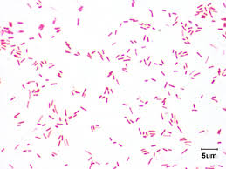

Case 4: AG, an 18 year old female has recently started her University degree in medicinal chemistry. Two weeks into her degree, AG started to experience a severe migraine, fever, and joint stiffness. AG visited her GP and was told that she had the flu and was told to get some bed rest and drink plenty of fluids. Overnight AG’s condition worsened; bright lights caused intense pain and her neck became stiff. Her friends phoned an ambulance and she was quickly admitted to hospital. After being found positive for Kernig and Brudzinski signs, a lumbar puncture was performed to retrieve a sample of cerebrospinal fluid (CSF). Your laboratory assistant has cultured a sample of this CSF and provided you with a plate of the pathogen for identification. Your assistant points out that this organism can only grow in when an increased amount of carbon dioxide is provided (the technical term for this is “capnophile”). After carrying out a Gram stain of the CSF you observe the presence of Gram-negative cocci inside the patients neutrophils.
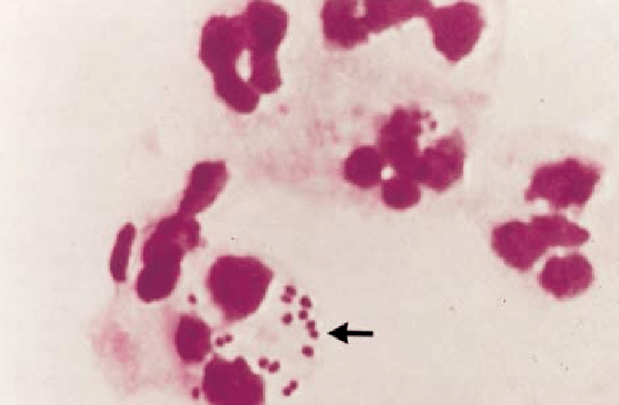

Case 5: JH celebrated his birthday by purchasing custard pies, which he happily consumed at the office lunch break with his colleagues. By mid-afternoon, everyone in the office experienced bouts of vomiting. The blame seemed to rest on the custard pies, which JH admitted had not been refrigerated since he bought them the day before. Your laboratory assistant has cultured a sample of the custard pie and has provided you with a plate of the pathogen for identification. Your assistant points out that this organism can grow in both the presence and absence of oxygen (the technical term for this is “facultative anaerobe”) and further testing revealed the organism possessed the enzymes “catalase” and “coagulase”. After carrying out a Gram stain, you observe the presence of Gram-positive cocci.
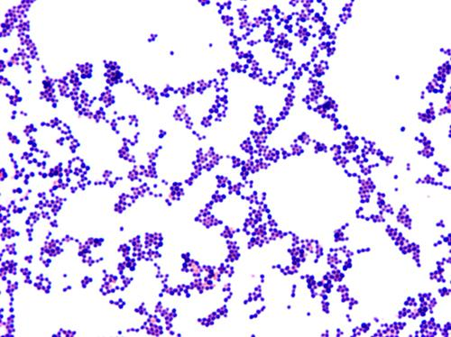

Guidance for your presentation

Use your findings and the information provided by your laboratory assistant to identify the pathogen – the flow chart on the last two pages of this document will help!

In your presentation you should start by showing the case you were presented with and then describe the steps you took to identify the pathogen. Did your laboratory assistant carry out any additional tests for you (e.g. the oxidase test in case 3)? Do some searching online and find out how these tests work so that you can tell your audience.

You should then go on and describe the infectious disease your patient is suffering from, considering the following points:
- What are the common symptoms of the disease (e.g. in case 4, what are Kernig and Brudzinski signs?)?
- Are any groups of individuals more at risk from infection than others (e.g. in case 2, why was the GP worried when he found out the AO worked with animal hides?)?
- Can you find any information on how the pathogen causes the disease (e.g. in case 1, the paralysis described in the case is caused by a toxin – how does the toxin work?).
- Can you find any pictures to put in your presentation?
- Finally, could you describe how is the infection normally treated?

If you have a copy of PowerPoint you can record a presentation at home following the instructions at this link: https://support.microsoft.com/en-us/office/record-a-slide-show-with-narration-and-slide-timings-0b9502c6-5f6c-40ae-b1e7-e47d8741161c. Please include audio narration with your slides, not video narration.

If you have a copy of Keynote (e.g. if you have an Apple computer) you can find instructions for recording a presentation here:
https://support.apple.com/en-gb/guide/keynote/tan8a5df9cc5/mac

Please e-mail a copy of your presentation to Stem@leeds.ac.uk no later than Friday July 30th 2021. Dr Randall will then provide you with some feedback by the middle of August at the latest.
Identification of Microbes
Note: This is a simplified version of the flow charts used in medical microbiology laboratories
Gram stain
Gram-negative |  |  |  |  | Gram-positive
bacilli (rods) |  |  |  |  |  |  | Cocci (spheres)
growth in oxygen?
 |  | Yes |  |  | no
Bacillus |  |  | Clostridium
 | (Bacillus anthracis) |  |  |  |  | (Clostridium tetani)
 |  |  |  |  |  |  | Catalase?
 |  | Positive |  |  |  |  | Negative
staphylococci |  |  |  |  |  |  | streptococci
Coagulase?
 |  | Positive
 |  | Staphylococcus aureus
 |  | Negative
 |  | Coagulase-negative staphylococci
haemolysis on
fresh blood agar
α |  |  | β |  |  |  | None (γ)
‘viridians’ streptococci |  |  | Streptococcus pyogenes |  |  |  | Enterococcus faecalis

Key continued…

…key continued

Gram negative
 | Bacilli (rods) |  |  |  |  | Cocci (spheres)
oxidase test |  |  |  | Requires extra CO₂ for growth?
 |  |  |  | Yes |  | No
 |  |  | Neisseria  (Neisseria meningitidis) |  |  |  |  |  | Moraxella
oxidase negative |  |  |  | oxidase positive
 |  |  |  | pigment
 |  |  |  | blue-green |  | brown
 |  | Pseudomonas aeruginosa |  |  |  | Pseudomonas fluorescens
Enterobacteriaceae
Lactose fermenter?
 | Yes (red on MacConkey agar) |  |  | No (yellow on MacConkey agar)
 |  | Proteus vulgaris
API 10S
Escherichia coli
Enterobacter aerogenes
Klebsiella pneumoniae
Serratia marcescens

