Campus Tour Training

This handbook offers guidance on how to deliver a campus tour during a school visit. You should bring this guide with you for on-campus events as you may be asked to give a tour. This handbook offers guidance on the route you may wish to take, buildings you should visit and some facts about the University which you may find useful to share, depending on the age group of the students.

Start of Tour:
Begin your tour by introducing yourselves (name, subject and year of study, any societies/sports you are involved in.)
Quickly go round the group and ask what subjects people are interested in. Explain that you will point departments out as you go round.
Enter the Parkinson Building and find a quiet area to talk to the whole group, preferably near (but not in front of) the information desk.

Parkinson building:
- The Parkinson Building is based on the design of the Los Angeles City Hall; built in 1930s. It is our main University building and features on our logo. It can be seen all across Leeds.
- There is the Stanley and Audrey Burton art gallery which offers both innovative temporary exhibitions and displays treasures from the University Art Collection. It has free admission.
- Treasures Gallery opened recently and amongst these treasures is a rare copy of the first folio containing the plays of William Shakespeare. Other gems include a Tudor cookery book printed in the time of Elizabeth I and a map and compass used by the first prisoner to escape back to Britain from Germany in the First World War, handwritten materials by the Brontës and Oscar Wilde, alongside manuscripts by the finest contemporary writers.
- Parkinson Court is normally buzzing in term-time with students meeting for lunch, using the PowerPoints to work wirelessly on their laptops or visiting one of the many events such as Careers Fairs, Study Abroad Fairs or Art Installations.

Brotherton Library:
Before entering the library, you may wish to explain the following:
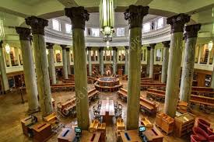
- The Brotherton Library is the biggest research Library in the North of England, and is one of 4 libraries on the University campus (other include the Laidlaw, Edward Boyle and Health Sciences libraries).
- In total there are over 2.8 million books in the libraries and access to 4 million online.
- The Brotherton is where books are stored for Arts, Humanities and Languages courses, but students can use other libraries too.
- It is home to the Special Collections, which houses rare and archived materials and all items are accessible to students. You may wish to talk about your own experiences using the Special Collections.
- Take students through the reading room (remember to stay quiet) and into the West Building.
- There are multiple group study spaces and desks with plug sockets like these across campus, and free Wi-Fi for students. There is a computer cluster in the West Building and various clusters across campus (many of which are open 24/7). Or, you could borrow a laptop from the libraries on short-term loan.

Michael Sadler Building:
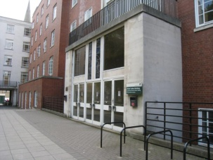
- Houses the School of Modern Languages & Cultures, including History, Philosophy (and History of Science) and Linguistics.
- Offers one of the widest range of languages courses in the country; from Thai to Russian
- You don’t have to do a languages degree to study a language at University, but you can pick up language modules through Discovery Modules. There are a number of languages you can pick up from scratch such as Russian, Arabic and Beginners Italian.
- You may also be able to switch your course to joint honours you are really enjoying your Discovery Module (that goes for other Arts and Humanities courses too, not just languages)

Great Hall Cloth Workers Court and School of Design:

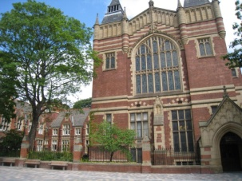
- The Great Hall opened in 1874 as part of the original Yorkshire College buildings, along with Baines Wing. The design of the Great Hall is actually based on that of Memorial Hall at Harvard University.
- It plays host to major events at the university, including graduation ceremonies (but you may have exams in there too!).
- To the left is Cloth Workers Court, this leads to the Institute of Communication Studies which houses media rooms, radio broadcasting facilities, television studio and cinema.
- To the left of this is the School of Design.

Leeds University Union:
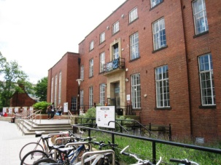
- First students’ union in the UK to be awarded an ‘Excellent’ status by the National Union of Students (NUS). First Union in the country to achieve the NUS Gold Standard, achieving a second gold star for its 2012 activities. There are now still only 3.
- The second highest ranking Student Union in the UK according to the NSS (National Student Survey) student satisfaction score of 92%
- Named top for not-for-profit bar operations and commitment to lowering impact on the environment.
- Union Upgrade - £16.8 million refurbishment, due to complete Easter 2017. Updates include two theatres, 4 studios for society rehearsals, expanded cafes and market square. You can now buy food from the likes of ‘Wok & Go’ and ‘Humpit’.
- Over 310 societies from debating to drama (add your experiences)
- Our Law Society has been awarded NUS society of the year
- Elected Student Exec
- Award winning student newspaper, TV and radio stations – Guardian Student Newspaper and Student Radio of the Year
- Support and advice for students (financial and welfare advice, will check accommodation contracts for you). Advice is professional, confidential and independent of the University.
- Joblink for term time employment that fits around your studies.
- Mini town centre: shops, bars and music venues, opticians, beauticians, Leeds branded clothing, café, salad bar, hairdressers, bank etc.
- Mention Amber Cars (student cards) and the Night Bus (£1 and runs until the last member of the Union staff leaves the building)

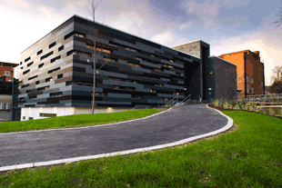
Stage @ Leeds:

- The facilities include a 180-seat main theatre, a ‘black box’ theatre for more intimate performances, a mirrored studio and various backstage rooms.
- Students who study theatre and performance use this space as well as some of our clubs and societies like Opera society, ballet and street dance.

Refectory:

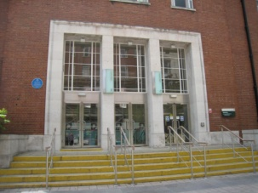
- The refectory provides dining for 600 people at one time. Cuisine includes sushi, noodles, salads, Italian and much more.
- If you are in on-campus catered accommodation, you will eat in the refectory. Explain how dining cards work. However, you can also eat in the refectory if you are self-catered.
- We’re a Fairtrade university, and the refectory ensures all its products are locally sourced and Fairtrade where possible
- It is also a venue for high profile concerts, with a capacity of 1000. Since the late 1960s the Refectory has hosted some of the most important acts around, including Led Zeppelin, Bob Marley, Rolling Stones and Elton John. Perhaps one of the most famous live recordings ever made, The Who Live at Leeds, was recorded in the Refectory.

More recently, it has played host to the likes of:

The Strokes
- Labrinth
- Arctic Monkeys
- Kaiser Chiefs
- James Brown
- Muse (recorded live for MTV)
- Franz Ferdinand
- Rizzle Kicks
- Chase and Status headlined the most recent Summer Ball

Careers Centre:

- Note the location of the Careers Centre and its assistance (organising careers events, mock interviewing, CV support, discovery modules etc.)
- Leeds is in the top 10 for graduate recruiters
- Careers support is a really valuable resource; students are encouraged to use it from year one, careers service is available for life.
- Year 1 – ‘Leeds for Life’ to help students identify their skills gaps and find ways to fill them. There is an online ‘living CV’, as well as information about opportunities outside of your course.

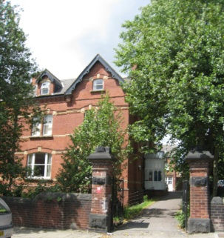

Walk past Charles Morris halls:
Explain what halls are like, did you stay in halls? Was it ensuite/catered?
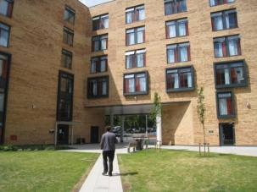
- Catered on campus hall
- 625 students in Charles Morris
- 39 week contract
- Social living/kitchen space with TV in each flat
- Laundry facilities, Wi-Fi
- Common room with pool tables, table tennis, flat screen TVs and comfy chairs
- 24 hour staffed reception
- Disabled parking available
- Cycle storage

Sustainable Garden:
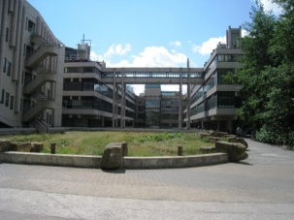
- It’s an edible garden run by students and staff.
- Aims to improve campus biodiversity and engages everyone whether enjoying the produce, working the garden, sitting in it and more!
- There are weekly gardening sessions where staff and students can pick the food and also get taught how to do it themselves
- Sustainability at the University is taken seriously, making sure we have a positive impact in society, and on the environment – you can even take discovery modules in it as a first year!

Roger Stevens:
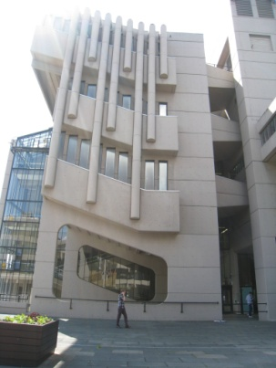
- If possible find an empty lecture theatre to take the group into. Theatres 17 and 1 are on ground floor level (Level 7). Explain what a lecture is like using your own experience.
- Roger Stevens houses 25 lecture theatres ranging from 80 to 300 seats, a café and Print and Copy Bureau (where students often get their final year projects published).
- Most students will have a lecture at some point during their university career.

Walk to The Edge: (you might want to point out the ducks in the pond)

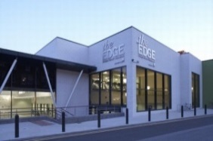
- The £12 million sports centre opened in 2010, it is Leeds' largest indoor sports halls with performance sports floors and lighting. It also boasts a fantastic 25m 8 lane swimming pool (touch sensors at each end to track lap times), Sauna/ Steam rooms and under floor heating in the poolside changing rooms.
- The largest fitness suite of any UK university with state-of-the-art equipment – over 250 machines. Each cardiovascular machine incorporates TV which provides Freeview and Sky Sports through a 19 inch monitor. It is also fully compatible with iPods that you can enjoy by plugging your headphones into the screen.
- You can sync your workout with apps such as Runkeeper and MyFitnessPal.
- There are a number of wheelchair compatible machines and The Edge has won an IFI (Inclusive Fitness Initiative) award for accessibility.
- Squash courts and climbing wall
- 125 weekly classes from Zumba to Body Attack to Spinning in our dedicated Spin Studio.
- Club membership is included in your accommodation costs, for all University halls of residence.

The School of Music:

- This school has rehearsal and performance spaces, a recording studio and access to the Clothworkers’ Centenary Concert Hall where concerts are held featuring our own orchestras, choirs and bands, these are open to staff and students at the University.
- The hall can be seen by the golden cupola.

Laidlaw Library:

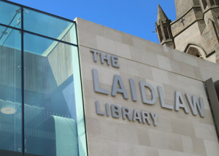
- The library contains high demand collections and core texts as well as housing Skills@Library, where you can sign up to study skills workshops.
- There are bookable group study areas and comfy places to study as well as a Café Nero.
- The library has solar panels and will even have a bee sanctuary on the roof, with 3 hives. Staff and students will have the opportunity to observe one hive and become bee keepers.

Depending on which course you are studying, you should point out your own course building, and include some facts.

